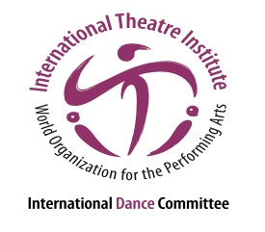
International Dance Symposium
of the 35th ITI World Congress
18 to 20 July 2017, in Segovia, Spain
“The city is our stage; the stage is our nature”

Performance Submission
Please fill in the information in the space provided below and send it to alma.llerena@itispain.es along with your CV and the dossier no later than May 15th 2017.

Performance title

Performance description in one line

Detailed performance description (max. 500 words)

Director

Choreography

Dramaturgy

Music Composition / Interpretation
Set design

Costume design

Light design

Dancers

Duration

Website / Trailer / Performance

Technical needs (please be VERY specific and list everything you will need).

List of artists traveling to Segovia for the performance
1.
2.
3. etc.

Full Name

Address

City / Zip Code / Country

Phone (with country code)

Email

