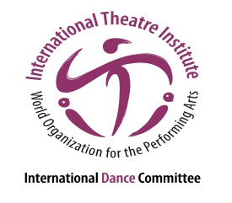
International Dance Symposium
of the 35th ITI World Congress
18 to 20 July 2017, in Segovia, Spain
“The city is our stage; the stage is our nature”

Lecture Submission
Please fill in the information in the space provided below and send it to alma.llerena@itispain.es along with your CV and the dossier no later than May 15th 2017.

Lecture title

Lecture description in one line

Detailed lecture description (max. 500 words)

Name of the lecturer

Duration (maximum 15 minutes)

Website / Videos / Performance

Technical needs (please be VERY specific and list everything you will need).

List of other lecturers that would be traveling to Segovia
1.
2.
3. etc.

Full Name

Address

City / Zip Code / Country

Phone (with country code)

Email

